[ Insert official UPAEP logo ]
UPAEP · Decanato de Ingenierías
EVIDENCE — US15-T9
Test manual irrigation
SmartGreenAI: Cilantro Crop

1. Task information
Task ID | US15-T9
User Story | US-15 — Manually activate or deactivate irrigation
Sprint | Sprint 3 (2026-10-12 – 2026-10-30)
Week | Week 3
Responsible | Vicente Rocha Alfaro
Peer reviewer | Oscar Abraham Talavera Nava
Planned / actual hours | 1.5 h / 1.5 h
Completed on | October 29, 2026
Status | Done

2. Task description
Test ON, OFF, duration expiry, unauthorized user and offline device (command must expire) on the simulator and, if the relay is available, on the ESP32.

3. Completion conditions
✓ Condition 1: All five cases executed.
How it was verified: The five cases were executed: ON, OFF, duration expiry, unauthorized user and offline device.
Command sent while the device was offline (1 rows; US15-T9_Test_Manual_Irrigation_1.csv)
id | action | status | created_at | expires_at
cmd-5efb7dcf93ef | ON | EXPIRED | 2026-09-29T04:40:13.918Z | 2026-09-29T04:41:13.918Z
SQL: SELECT id, action, status, created_at, expires_at FROM actuator_commands WHERE id = $1
Calls of the test (attached: US15-T9_Test_Manual_Irrigation_3.txt)
POST /api/actuators/ACT-PUMP-01/command
Authorization: Bearer eyJhbG…
{
"action": "ON",
"duration_min": 1
}
→ HTTP 201 Created (20 ms)
{
"id": "cmd-12404b78b7ef",
"actuator_id": "ACT-PUMP-01",
"action": "ON",
"duration_min": 1,
"source": "MANUAL",
"status": "PENDING",
"reason": "Manual control from the dashboard.",
… (6 more lines in the attached file)
POST /api/actuators/ACT-PUMP-01/command
Authorization: Bearer eyJhbG…
{
"action": "ON",
"duration_min": 5
}
→ HTTP 201 Created (19 ms)
{
"id": "cmd-ded059af76da",
"actuator_id": "ACT-PUMP-01",
"action": "ON",
"duration_min": 5,
"source": "MANUAL",
"status": "PENDING",
"reason": "Manual control from the dashboard.",
… (6 more lines in the attached file)
POST /api/actuators/ACT-PUMP-01/command
Authorization: Bearer eyJhbG…
{
"action": "OFF"
}
→ HTTP 201 Created (15 ms)
{
"id": "cmd-fafa5b8a103d",
"actuator_id": "ACT-PUMP-01",
"action": "OFF",
"duration_min": null,
"source": "MANUAL",
"status": "PENDING",
"reason": "Manual control from the dashboard.",
… (6 more lines in the attached file)
POST /api/actuators/ACT-PUMP-01/command
{
"action": "ON",
"duration_min": 1
}
→ HTTP 401 Unauthorized (6 ms)
{
"status": 401,
"code": "ERR_AUTH_REQUIRED",
"message": "A Bearer token is required. Sign in to obtain one.",
"details": []
}
… (19 more lines)

✓ Condition 2: Every case has a pass/fail result.
How it was verified: Every case has a pass/fail result: 5/5 PASS.
✓ Condition 3: Screenshots saved.
How it was verified: Screenshots saved (irrigation history after the test).
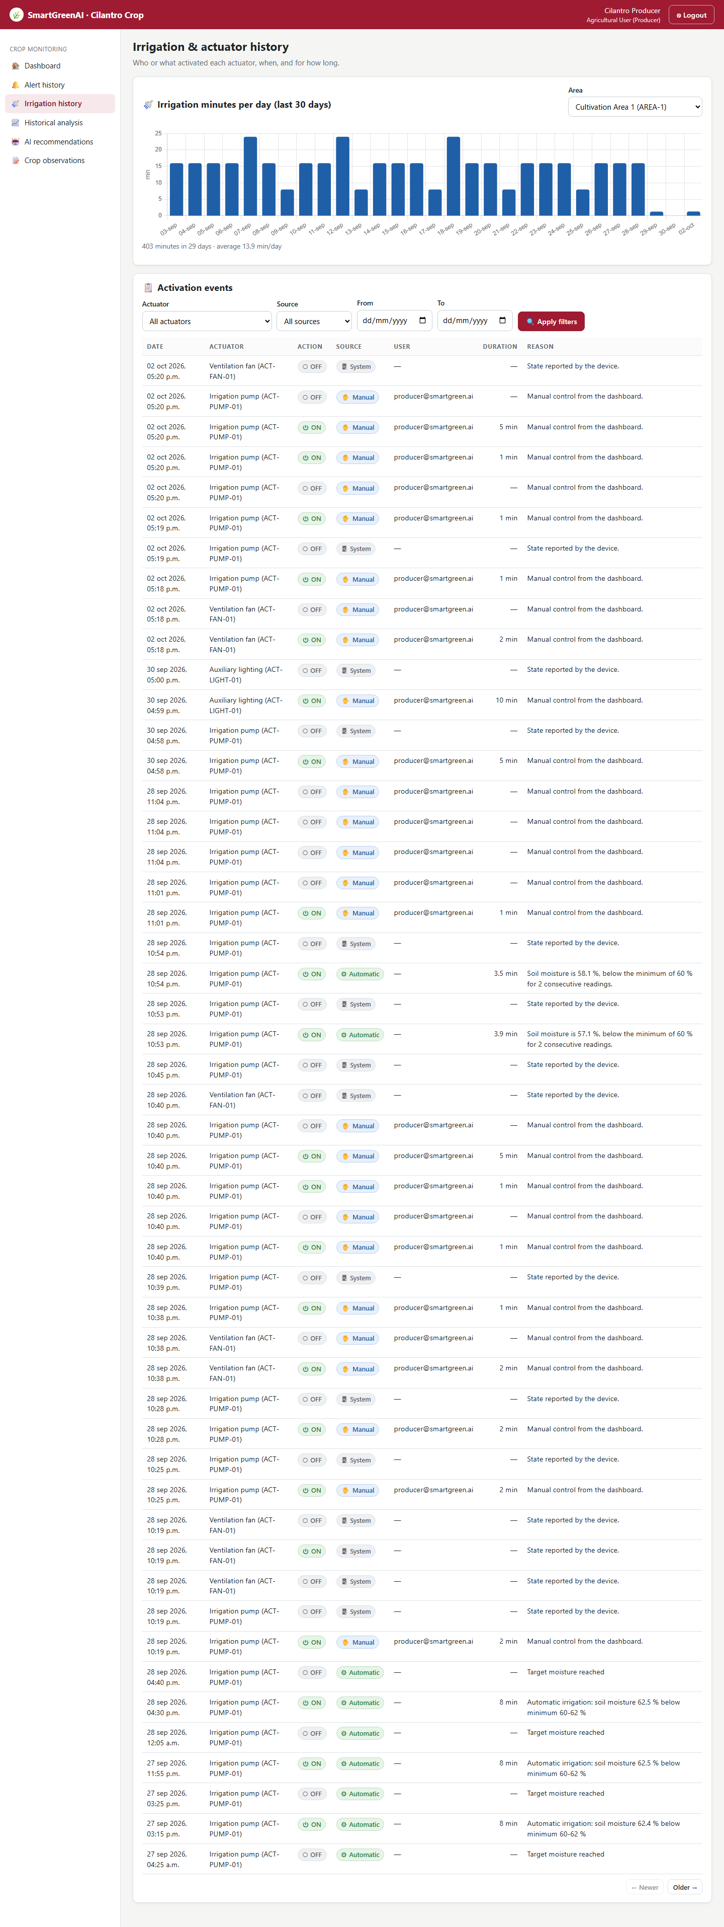
Figure US15-T9-1. Irrigation history after the tests: ON/OFF events with source Manual and the user. (US15-T9_Test_Manual_Irrigation_4.png)
✓ Condition 4: Evidence: Test table with results and screenshots.
How it was verified: Test table with results and screenshots.

4. Manual irrigation tests
ID | Case | Steps | Input | Expected | Actual | Result
MI-01 | ON | POST command ON 1 min; device executes | ACT-PUMP-01 ON | pump ON, command EXECUTED | HTTP 201; state ON | PASS
MI-02 | Duration expiry | Wait for the duration (device auto-OFF) | 1 min | pump OFF after about 60 s | OFF event after 0 s | PASS
MI-03 | OFF | ON 5 min, then OFF before the end | OFF | pump OFF | HTTP 201/201; state OFF | PASS
MI-04 | Unauthorized user | POST command without a session | no token | 401, nothing queued | HTTP 401 ERR_AUTH_REQUIRED | PASS
MI-05 | Offline device | Device not polling; wait more than 60 s | ON 2 min | command EXPIRED, never executed | status EXPIRED | PASS
Totals: 5 cases · 5 PASS · 0 FAIL

5. Attached files
- US15-T9_Test_Manual_Irrigation_1.csv
- US15-T9_Test_Manual_Irrigation_2.sql
- US15-T9_Test_Manual_Irrigation_3.txt
- US15-T9_Test_Manual_Irrigation_4.png

6. Traceability
Related requirements | FR-16, FR-17
Implementation | —
Verification | integration/commands.test.js; e2e/irrigation.spec.js; Postman folder 08

7. Sign-off
Role | Name | Date | Signature
Responsible | Vicente Rocha Alfaro | October 29, 2026
Peer reviewer | Oscar Abraham Talavera Nava | October 29, 2026
Product Owner acceptance | Alexis Enrique Valle Parra | October 29, 2026
Approval record: Sprint 3 Review & Delivery (October 30, 2026): "Product Owner accepted the seven user stories: all acceptance criteria met."

